Comparison of Simulated vs. Observed Disease Onset Times
Model | Err( days) | Err(hours)
Dmcast | -25.12 | -602.93
Epi | -14.57 | -349.62
Ipi | -4.91 | -117.82
Magarey | -6.72 | -161.23
Rule310 | 2.98 | 71.47
UCSC | NaN | NaN
laore | 7.44 | 178.67
misfits | 8.64 | 207.47

The table presents the mean error in predicting the onsetDate across all sites. A general trend among the models is the earlier prediction of the date of symptom appearance and, by extension, the initial infection.

Comparison of set phenological parameters vs optimized ones
Before calibrating the disease model parameters, the phenological parameters were optimized using the same calibration method. The new parameters are generally lower than the default settings. The calibration, therefore, reduces the parameter values, which implies a later development of the phenological phases when compared to the previous (default) situation (?).

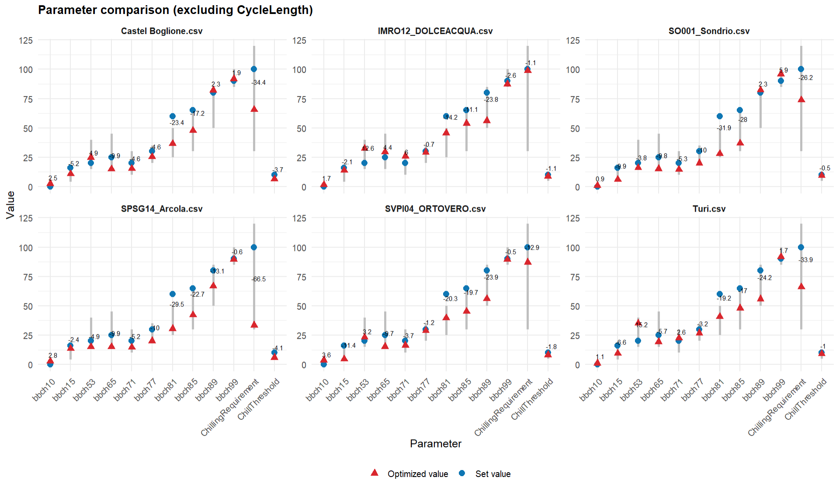
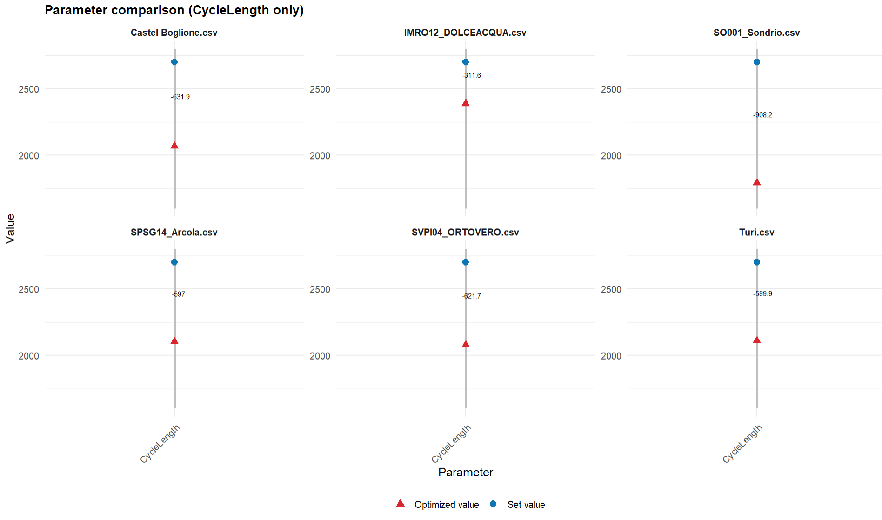
Consequently, when comparing the BBCH grapevine evolution during the season, we notice that the BBCH phase derived from the optimized parameters shows a time shift forward (i.e., it occurs earlier). This is the result of a set of parameters with lower values. Lower parameter values cause a delay in the BBCH evolution. Example: If the chill threshold is lower, the model becomes more demanding in terms of cold accumulation. Consequently, the dormancy release is slower because achieving the chill requirement takes more days.
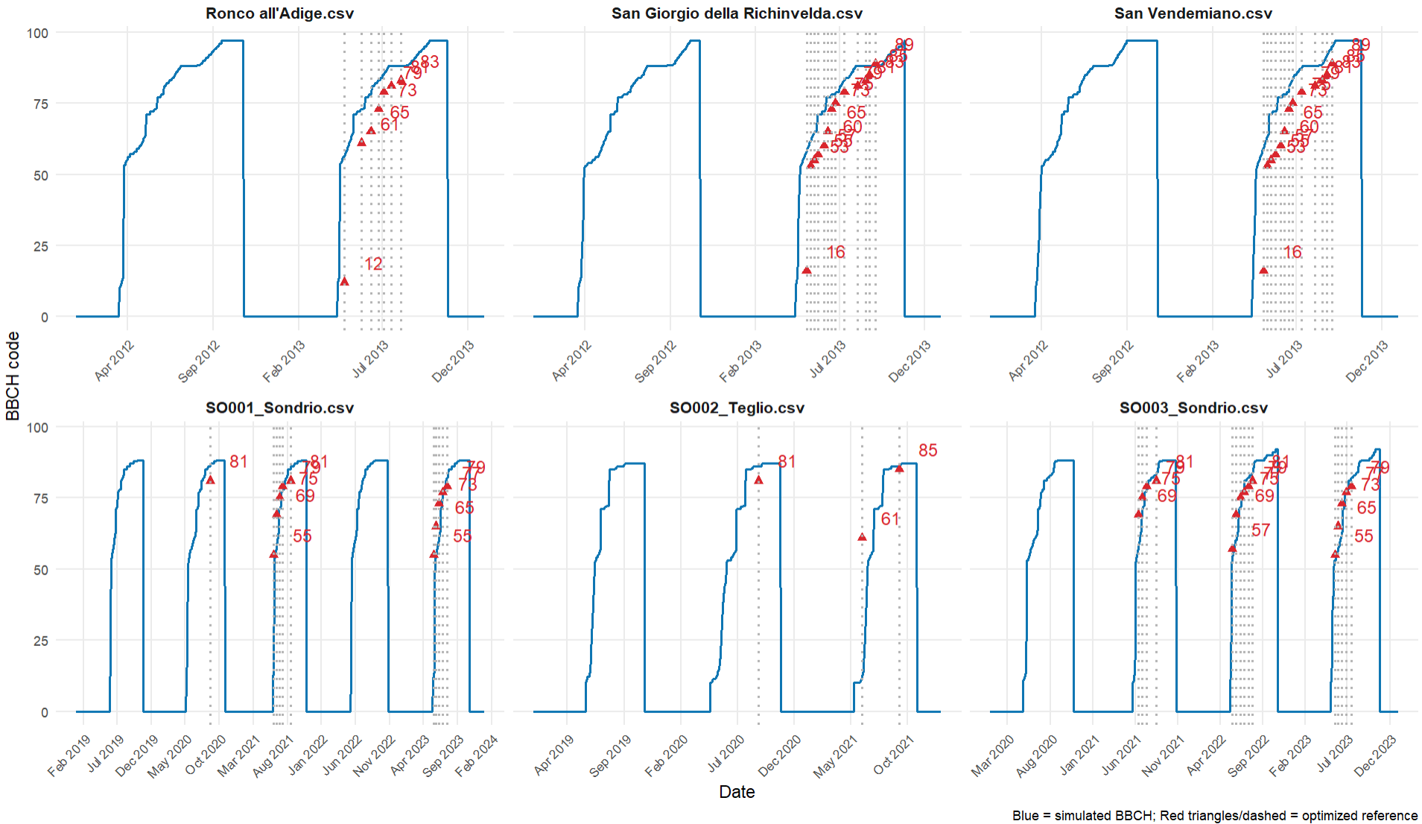
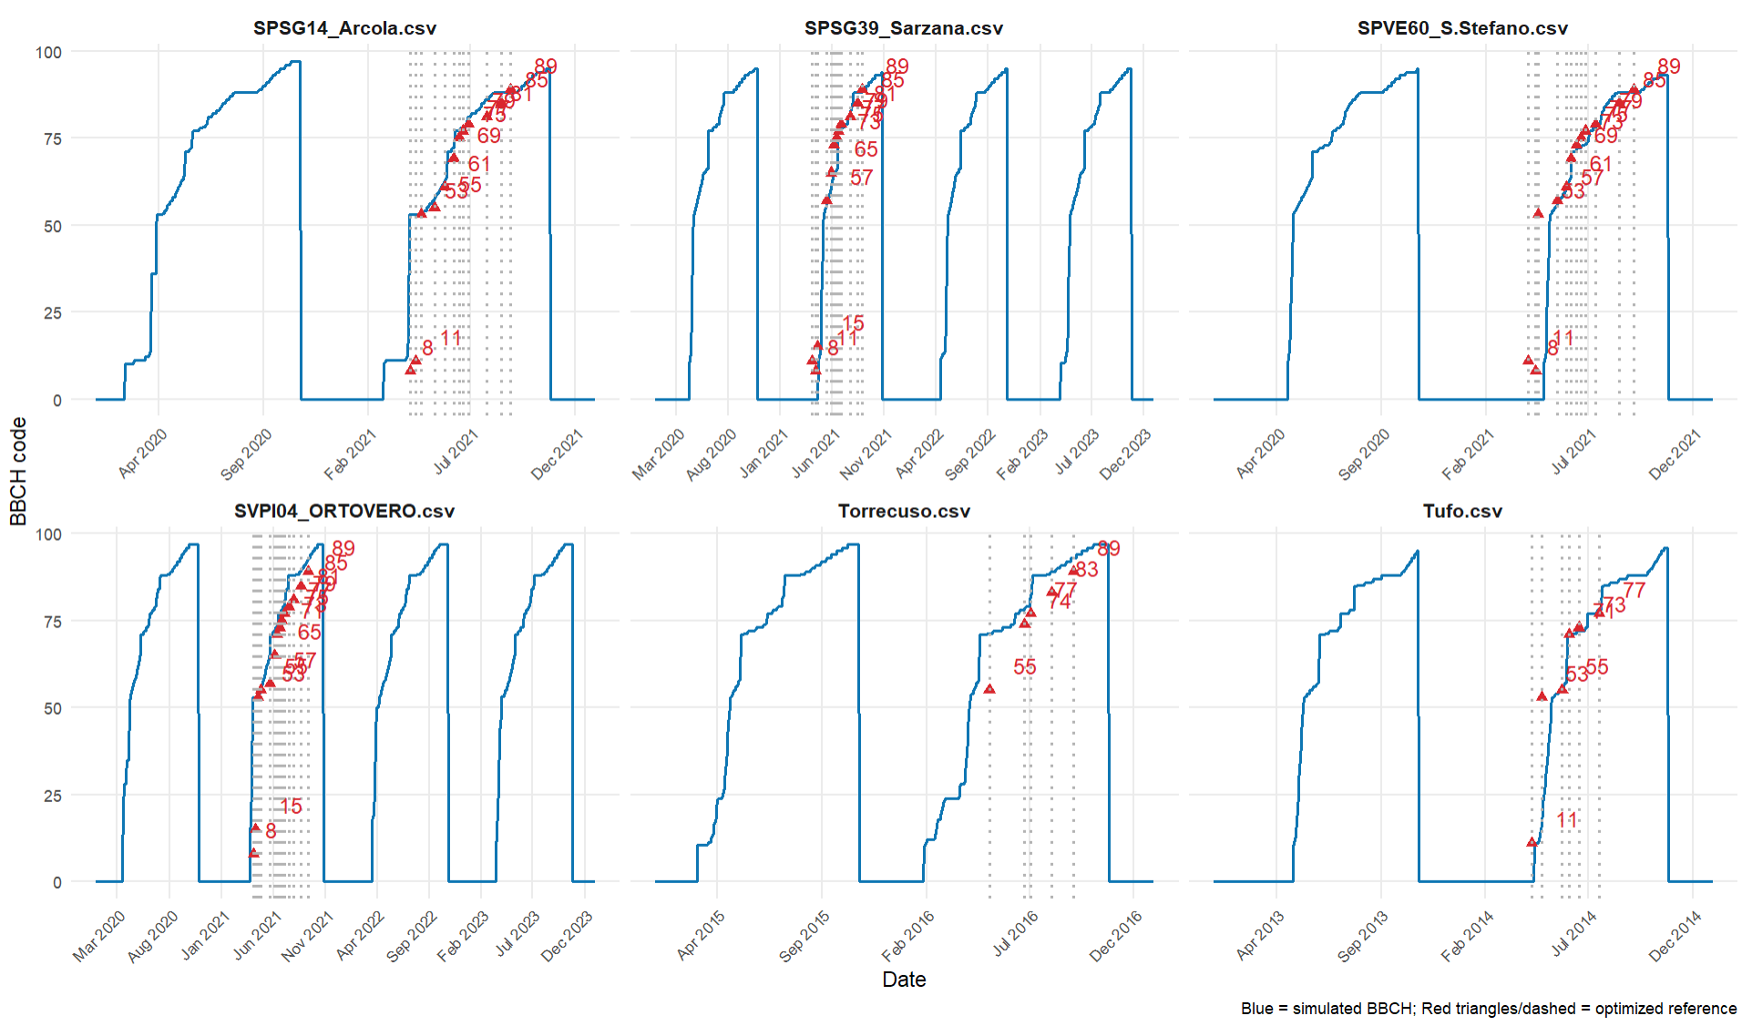
In many cases, the optimized BBCH stage is achieved before the simulated BBCH stage.This is likely due to the fact that the optimized chilling requirement also has generally lower values. In these specific cases, a lower requirement makes it possible to end dormancy earlier.

